U20860/M25187 – M451 – Supply Chain Management

Problem 1: Case Study of Cadbury


S. Name:
S. ID:
Table of Contents
Introduction 3
Brief historical development of the company 4
Global mapping of network, suppliers and strategic partners 6
Product design and production planning 8
Use of information and technology 10
Customer service and pricing 12
Ethical and environmental policy 14
Conclusions and recommendations 17
References 19

Introduction
SCM (Supply chain management) is concerned with the direction of the flow of operation and materials used in the production process (Hazen et al., 2020 pp. 510-537). Every company manages a strategic supply chain to increase profits and stay ahead of the competition. Companies' supply chains involve distributors, manufacturers, retailers, shippers, and suppliers. With that in mind, the main objective of this individual assessment is to examine Cadbury's supply chain management practices.
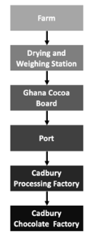
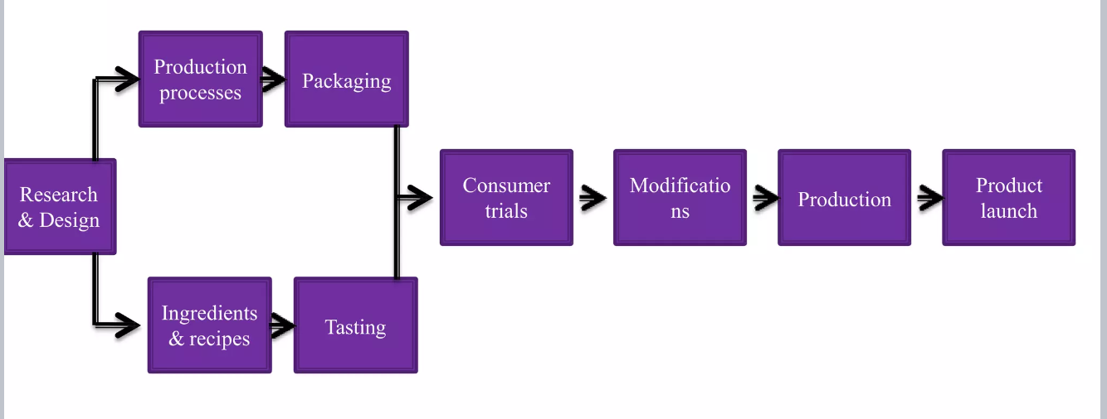
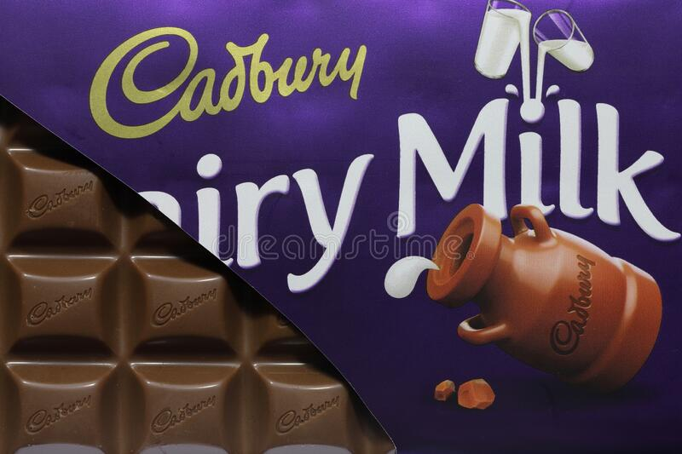
Figure: Cadbury’s Supply chain distribution channel
Source: Learner-made
The information gained from this study will aid in concentrating on current business operations and analysing how technological changes have disrupted Cadbury's methods. All the ethical and environmental policies the company has in place to manage its supply chain will be the focus of this discussion. As a result, this individual assessment will be useful for learning about the current state of Cadbury's production planning and customer service.

Brief historical development of the company
Cadbury established in late 1824 in Claremount, Tasmania, is a British multinational confectionery company. Cadbury is owned by Mondelez, a fast-moving consumer goods company with headquarters in the United States as of 2012 (Wordsworth, 2018). Cadbury's operations can be found in more than 60 countries, headquartered in London. Cadbury's mission since its founding has been to become the world's most successful confectionery company, and its offerings include a wide variety of chocolates. John Cadbury started the business in his family as a supplier of food and household goods. From its commercial beginnings in 1831, manufacturing has come a long way. In order to break into consumer markets, the firm relied on commercial manufacturing (Crawford & Bailey, 2022).
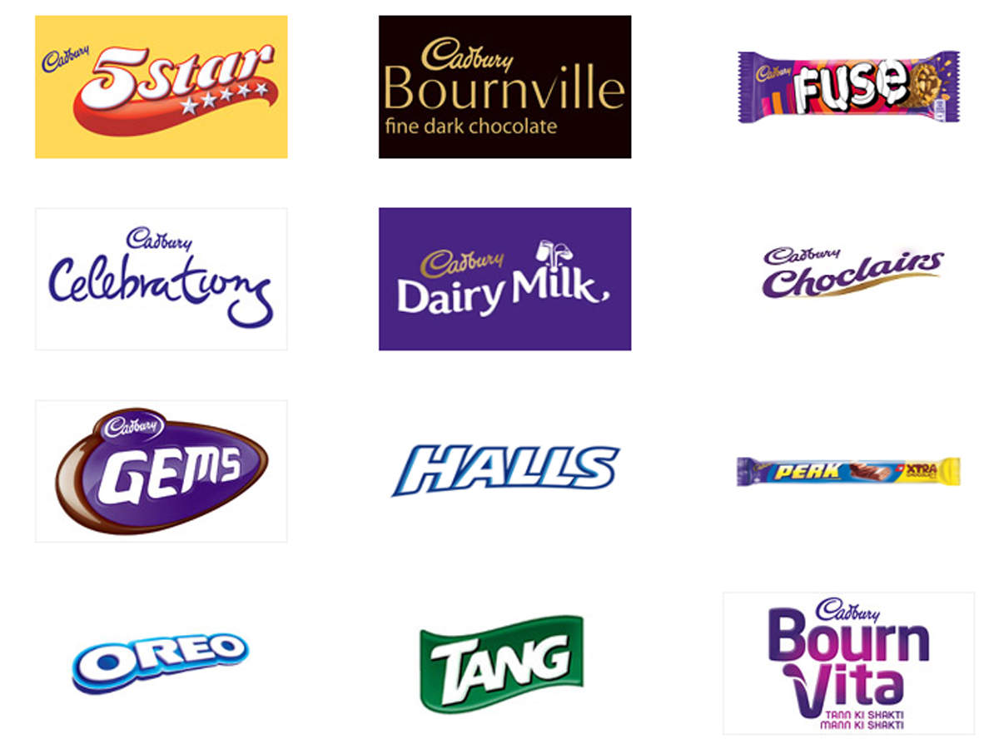
Figure: Cadbury Company’s products
Source: https://economictimes.indiatimes.com/magazines/panache/manufacturer-of-cadbury-to-donate-71-tonnes-of-biscuits-chocolates-in-12-cities/articleshow/75159468.cms?from=mdr
Cadbury is now involved in the milk-shake industry (GUPTA, 2022). William Cadbury commissioned the original Cadbury logo in 1905, and the company has won awards for its innovative candy ever since (Cadbury 2021). In 2010, the company was acquired by Mondelez International. Both companies were set up for long-term success by Mondelez's acquisition of Cadbury, which brought together two formidable food manufacturers (Just-food.com 2016).
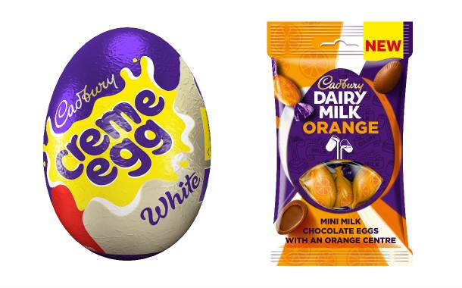
Figure: Mondelez international first product after acquisition with Cadbury
Source: https://www.foodbev.com/news/tag/mondelez-international/
The company's fortunes were determined by the variety of chocolate bars it offered as a representation of its portfolio. Using its expanding capabilities, the corporation increased its global footprint. Customers' requirements were prioritised, and the company's unique approach was leveraged to maximum effect in communicating with them. The company's international expansion was facilitated by this.

Global mapping of network, suppliers and strategic partners
The supply chain is essential to Cadbury's operations, as it ensures a steady flow of materials and products from their suppliers to their warehouses and, ultimately, to their customers across the world. The company addresses the transformation of raw materials into finished products through a series of interconnected systems. Each component of the logistics plays a vital role in its overall success. Cadbury's reliable logistic allows it to function effectively on a global scale (Waters, 2019). There are also stringent regulations governing the distribution channel to guarantee the quality and security of the products.
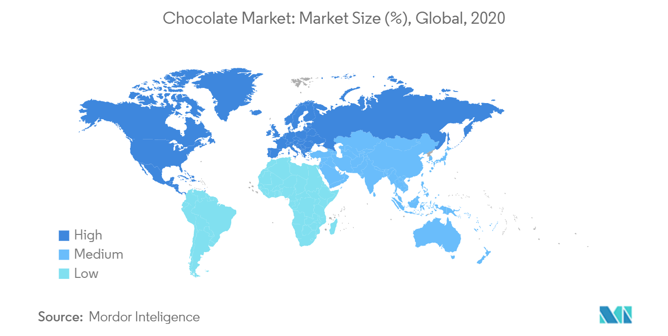
Figure: Chocolate market and demand
Source: https://www.mordorintelligence.com/industry-reports/chocolate-market
It has established relationships with reliable suppliers all across the world. Raw materials and production methods are acquired from all over the world. For example, the company gets its cocoa beans from Ghana, its processor from Singapore, and its sugar and milk from Australia (Neilson et al., 2018 pp. 400-424). The United States and the United Kingdom are the company's two largest markets. The cocoa beans used by the company come from many countries, allowing it to expand into new markets. The cocoa beans used by Cadbury are sourced from Ghanaian cocoa industry companies, one of the key raw materials used in the factory. Cocoa Life ensures the ethical and environmentally responsible sourcing of cocoa for Cadbury Dairy Milk (Neilson et al., 2018 pp. 400-424). The company's Chocolate Factory produced over 60,000 metric tonnes of chocolate, making it the largest chocolate factory in the Southern Hemisphere (Thehindubusinessline.com, 2018). The milk used to make British dairy chocolate bars since it comes from Tasmanian cows. Farmers in Selkley Vale supply most of the milk for Cadbury, UK (Cadbury, 2022). More than 70% of the company's total revenue comes from its common market like the US, UK, Australia, Canada etc (Cadbury, 2022).
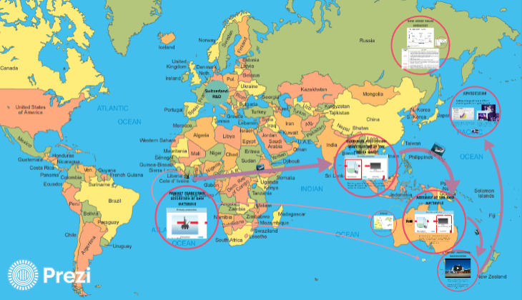
Figure: Cadbury’s SCM distribution from Australia
Source: https://prezi.com/ok17s8eismoc/cadbury-australia-dairy-milk-the-supply-chain/
Strategic alliances are in place on every continent for this company's global expansion. Hershey, which has the right to market Cadbury products in the US, is also a partner. Strategic alliances with organisations in numerous nations and regions provide the corporation with international bragging rights (Cadbury, 2022). Those that provide the factory with the cocoa beans and other ingredients needed to make chocolate are the company's suppliers. Aluminium foil used in packaging typically comes from a variety of international sources. Therefore, the supply chain's unique control ensures it continues to rank well among supply chain businesses.

Product design and production planning
With a continued emphasis on customer acquisition, the company's success may be attributed in large part to the widespread appeal of its products. After over 50 years in business, the company underwent a comprehensive redesign in 2020 (Desk, 2021).
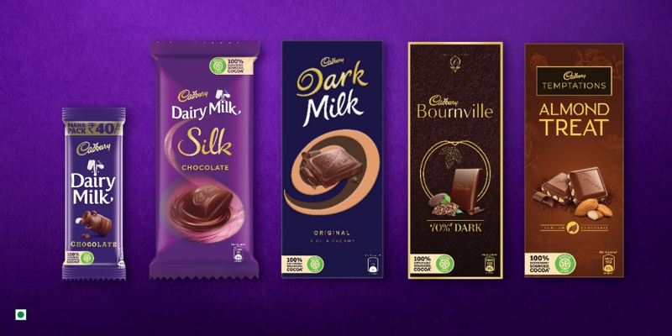
Figure: Product design
Source: https://indifoodbev.com/food-ingredients/cadbury-chocolates-reaffirms/
They were responsible for the construction of a distinctive appearance that has been restyled to appeal to consumers' need for a more natural and true experience when using the products. The company's packaging has been reimagined to give customers a sense of discovery and surprise with each purchase by emphasising the company's signature colour—dark purple (Bailey & Milligan, 2019). The product design has attracted Cadbury's customers, which can be seen as their success.
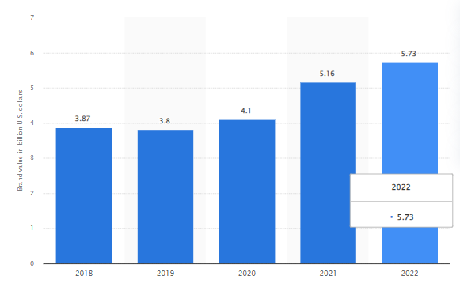
Figure: Brand value
Source: https://www.statista.com/statistics/1337772/cadburyr-brand-value/
Three-dimensional printing technologies are used in the company's research and development of Production process and planning. The implementation of these cutting-edge tools has helped streamline and enhance all of the operations (Ng et al., 2022 pp. 4327). Therefore, the versatility of 3D printing allows the company considerable leeway in product design, production, and innovation. New 3D printers are easy to clean, and the printed foods retain their shape and texture. It paves the way for the corporation to enhance the textures and structures of the products for consumer use. Production planning is used to maximise productivity inside the company. By employing such technologies as 3D printing, a business is better able to meet the needs of its customers for uniquely tailored items (Kumar & Kumar, 2020 pp. 1463-1467).
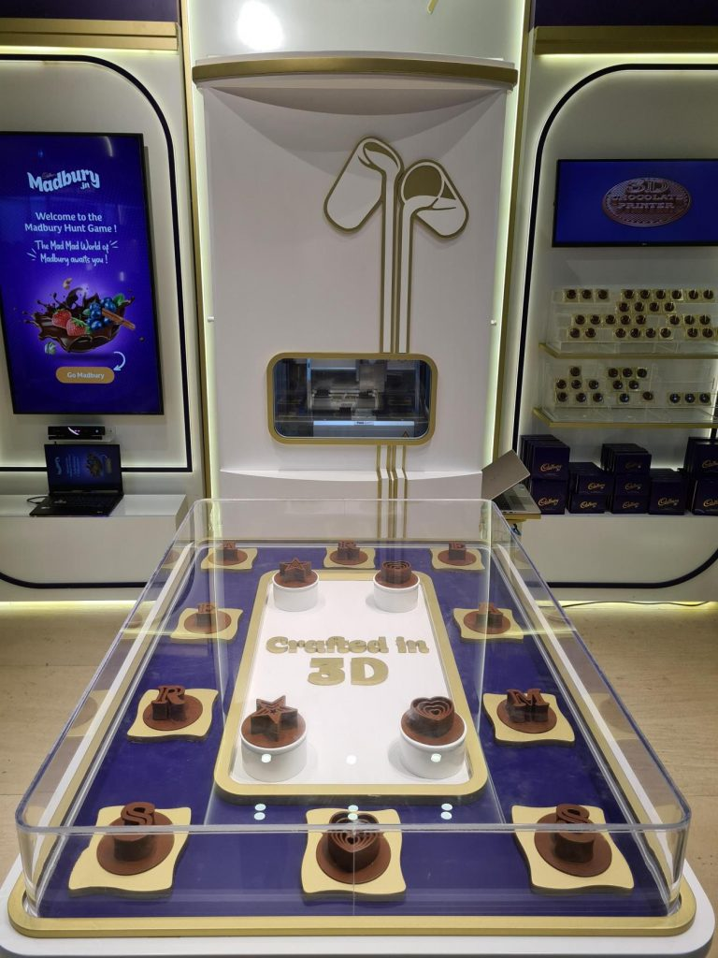
Figure: 3D printer at Cadbury
Source: https://www.todaystraveller.net/first-ever-3d-printed-cadbury-chocolates/
Improved food product design may result from the company's usage of 3D printing's cost-cutting, rapid prototyping, and streamlined production processes. Since 3D printing does not limit production based on the complexity of the product's design, manufacturers are free to experiment with new geometric forms for edibles.

Use of information and technology
Cadbury's success in the market is predicated on the strength of its technological innovation and IT (Chiyem & Christopher, 2022). In addition, the corporation has been observed implementing new production machinery and software in an effort to maintain its competitive edge. Since the company has a solid reputation in the FMCG sector and a large share of the market, it can confidently provide high standards of service and production enabled by cutting-edge technological advancements (Barrientos, 2019).

Cadbury is constantly enhancing its production and distribution processes by updating and modernising its supply chain system and related infrastructure. The enterprise resource planning (ERP) system is a possible piece of technology employed by the company, as it facilitates the integration of its extensive supply chain operations. Cadbury can manage the supply chain system better and keep track of the myriad moving parts because of the coordination of the process. The establishment of the ERP system motivated the organisation to introduce information and technology for better process integration. Cloud-based SAP is another cutting-edge piece of technology that has lately been implemented by the company in its supply chain operations. As a result of the ERP's support for advanced tech, the organisation is better able to anticipate and prepare for the future (Linkedin.com 2022).
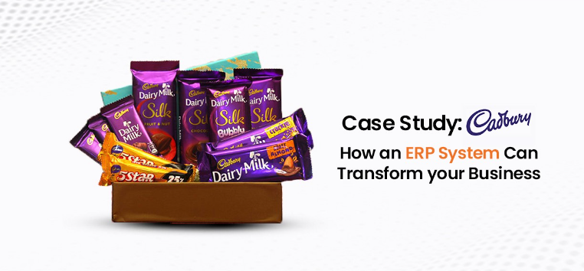
Figure: SAP using by Cadbury
Source: (Linkedin.com 2022)
SAP ERP has had several effects on Cadbury, including the provision of real-time and accurate information that has allowed manufacturers to hand over control of operations and reduce the likelihood of delays (Linkedin.com 2022). However, the organisation also uses computerised manufacturing to mass-produce the products. Automated production lines allow for the creation of a high volume of goods at a consistent quality and rate of speed. As an added benefit, information technology allows for adaptability in the manufacturing process.

Figure: 3D print at Cadbury
Source: https://webneel.com/daily/19-advertising-ideas-design-3d-cadbury-chocolate-brijesh-parmar
Additionally, 3D printing is used within the organisation to lessen the possibility of mistakes while keeping quality high (Kumar & Kumar, 2020 pp. 1463-1467). Because of this innovation, the company can print various chocolate forms instead of using the time-consuming and labour-intensive process of moulding them. Accordingly, the incorporation of technology has proven to have a beneficial effect on Cadbury.

Customer service and pricing
Unlike many FMCG companies, Cadbury has a well-developed distribution system. The use of the bulk-breaking method promotes the organisation's distribution procedure. As per its long history, Cadbury naturally dominates the global FMCG distribution market. From there, the chocolates are distributed to local grocery stores, supermarkets, retailers, cafes and department stores. Cadbury has maintained its product by providing customer service and pricing of products. The corporation has a dedicated customer care division, which ensures that all buyers are satisfied; 2.5 years to 70 years is the brand's demographic, so healthy hygiene and suitable size is significant for this company (Osidele, 2021).
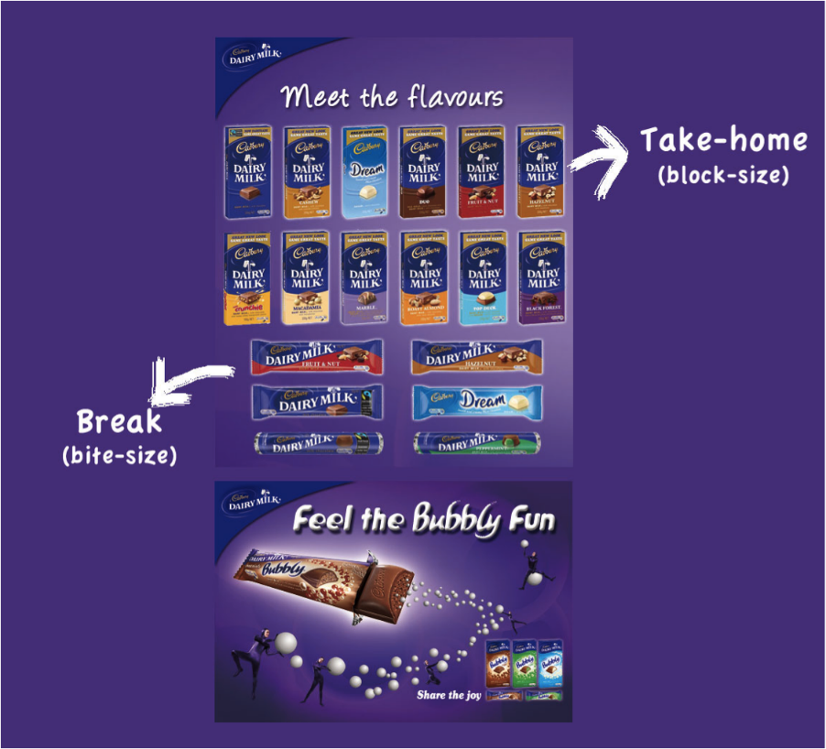
Figure: Brand strategy
Source: https://thecadburychocolatier.wordpress.com/cadburys-brand-strategy/
In order to provide a better experience for their buyers, the organisation answers their queries and addresses their problems immediately. Customers' queries can be cultivated and maintained with the help of professionals and other well-trained staff in the customer service department. In addition, businesses use market research and the quota sampling method to learn about customers' tastes (Onyike & Orga, 2022). Such instance, for Cadbury, this method has helped the company's suppliers and buyers stay on good terms.
Cadbury uses a mix of push and pulls marketing. Business owners use a pull technique to increase product awareness and sales. The company places a premium on clientele, which it reaches through publicity campaigns that provide sales and other discounts (Jinu, 2020). In contrast, the business uses a pull approach to reach all buyers, which pushes the products downstream through channels of distribution. In order to attract a wide variety of customers, the organisation maintains competitive pricing.
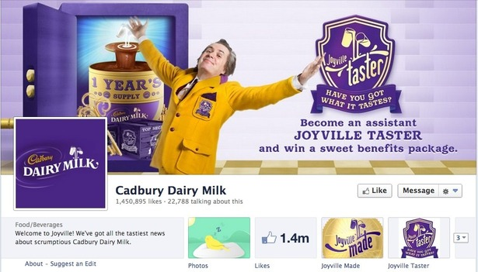
Figure: Social media post
Source: https://econsultancy.com/how-cadbury-uses-facebook-twitter-pinterest-and-google/
The business uses a bundling technique, grouping things that go well together and selling them at a discount. Consumers with lower and moderate incomes can take advantage of the discounted costs of the tiny chocolate packs. Both the organisation and its consumers benefit from this development. This means that Cadbury's production and distribution methods are well managed to attract a wide variety of consumers by social media.

Ethical and environmental policy
Agricultural, economic, and topographical factors reportedly pose serious difficulties for cocoa production. Ghana is the world's largest producer of cocoa. However, there are difficulties that have been managed at the moment, and the future of the cocoa production business is uncertain. It is due to limited revenue creation and the impacts of climate change. Due to low profits, the industry is in a dire financial strait. Young Ghanaians are no longer as interested in farming and are instead pursuing more industrialised occupations (Daghagh Yazd, Wheeler & Zuo, 2019). Their enthusiasm for cocoa production has undoubtedly been dampened as a result. Extreme drought and a wildly erratic rainfall pattern have been attributed to climate change, which is an environmental concern in and of itself. Because of this, Cadbury needs to put a premium on cocoa farming if it wants to survive. Cadbury has overseen a number of frameworks and initiatives aimed at ensuring the well-being of people and the industry as a whole.
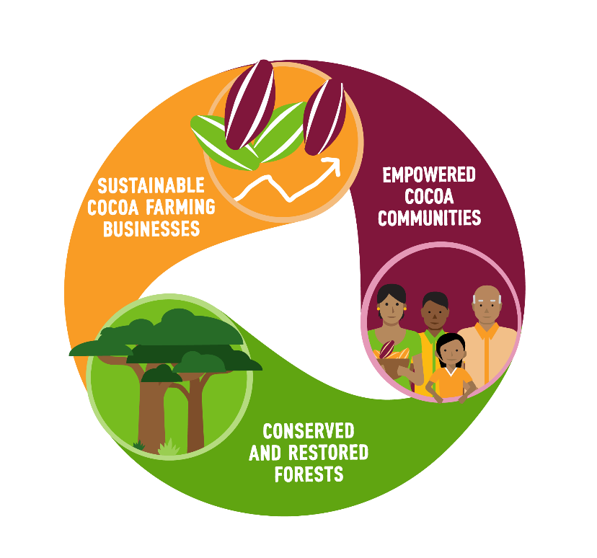
Figure: Cocoa Life Program initiatives
Source: https://www.cocoalife.org/the-program/approach
Cadbury's Cocoa Life Program is one of their promising initiatives; it seeks to assist in the development of a robust cocoa supply chain and the expansion of chances to improve the living conditions of cocoa farmers and their communities (Odoom, 2021). Cadbury was able to give the cocoa communities a better quality of life because of the scheme. In 2007, initiated a programme called Purple Goes Green (Stratton, 2021).
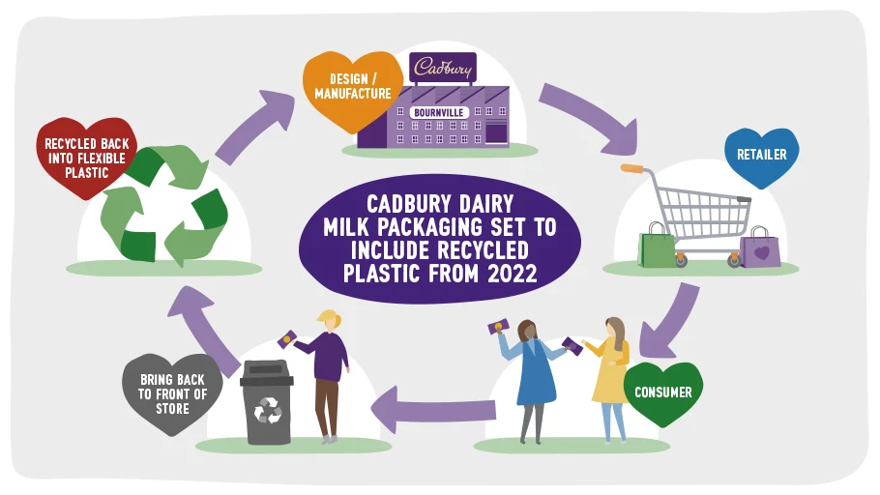
Figure: Green activity
Source: https://www.mondelezinternational.com/Snacking-Made-Right/ESG-News?mid=346576&pgno=1&fdpgno=1
The law was passed to address people's worries about the environment. It aided in lessening the environmental harm and pollution caused by Cadbury. Cadbury guarantees eco-friendly, farm-to-table sourcing. The company strives to source all of the cocoa used in its products ethically and sustainably.
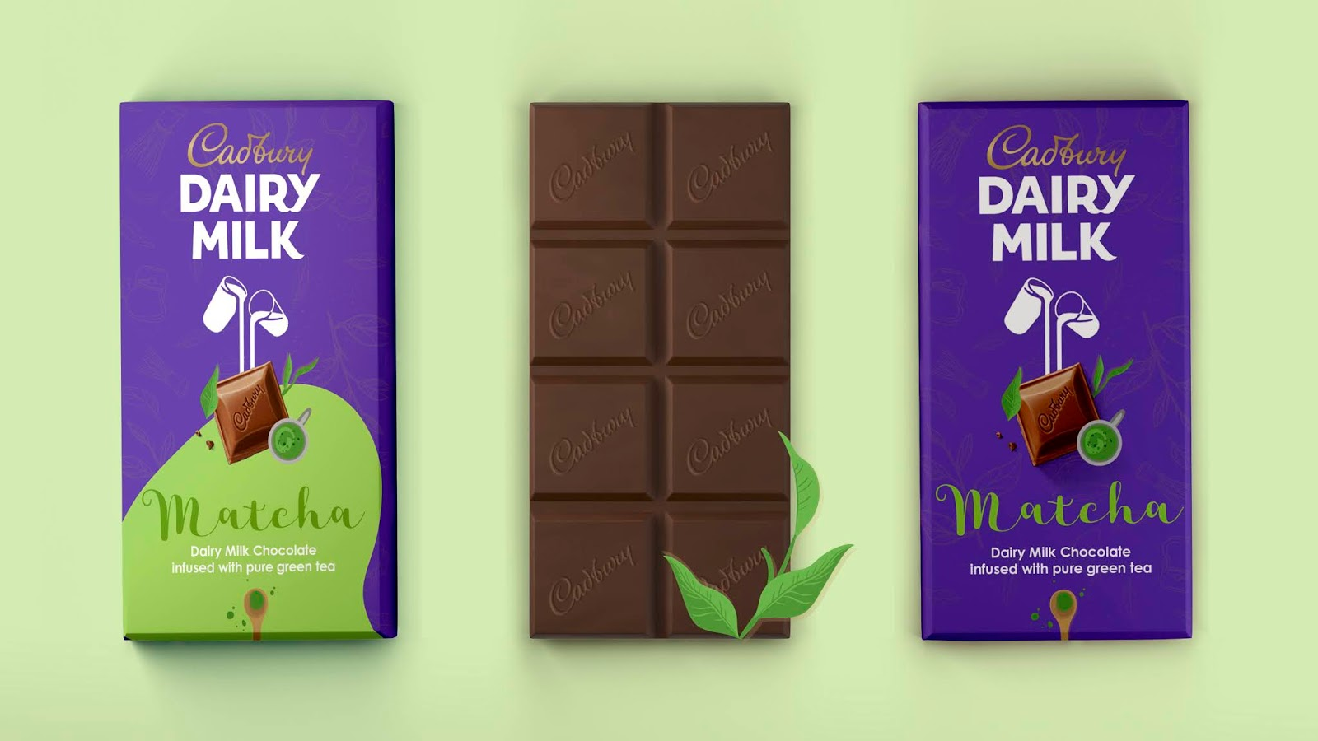
Figure: Purple Goes Green
Source: https://packagingoftheworld.com/2021/01/cadbury-dairy-milk-for-japan.html

Conclusions and recommendations
The analysis suggests Cadbury has a strong supply chain, from raw materials procurement to finished goods delivery. Various facets of product design and planning are implemented by professionals to aid in the process. In addition, the supply chain is aided by several innovative technologies that reflect the company's dedication to quality and excellence. Every step of manufacturing receives a boost from Cadbury's innovative procedures. The company, however, maintains a commitment to ethical and environmental practices. The company has supported numerous initiatives to improve the lives of Ghanaians and the cocoa industry.
Since the company has a solid foundation within the market and has grown steadily over the years, it may improve its supply chain management by integrating environmental concerns, the outlook for the future, and technology advancements.
The cocoa industry needs to invest in researching and producing plant-based components to create alternative flavours for a sustainable future. The company's future success depends on its ability to experiment and innovate constantly. Customers place a high value on companies that care about the environment; thus, this is another area where the target business should improve.
In order to lower emissions and broaden the company's consumer base, the corporation should provide more vegan-based alternatives. Right now, all of the company's packaging is made of plastic. However, to maintain a sustainable supply chain, the corporation should switch to environmentally friendly packaging. It needs to make sure that biodegradable packaging is used instead of plastic. The business should focus on integrating AI or machine learning into its supply chain system to optimise product creation and management. Technology integration can improve oversight and cut down on mistakes. Ultimately, it will aid Cadbury's efforts to manage its global supply chain. In ending child labour, the corporation must institute a stringent code of conduct for its suppliers and boost supply chain transparency. The corporation needs these initiatives can enhance its supply chain and make operations more accountable.

References
Bailey, S., & Milligan, A. (2019). Myths of branding: A brand is just a logo, and other popular misconceptions. Kogan Page Publishers. Available at: https://books.google.co.in/books?hl=en&lr=&id=nHl_DwAAQBAJ&oi=fnd&pg=PP1&dq=Cadbury+packaging+has+been+reimagined+to+give+customers+a+sense+of+discovery+and+surprise+with+each+purchase+by+emphasising+the+company%27s+signature+colour%E2%80%94dark+purple.+&ots=C9yDcbAb9s&sig=3hTqFsf-Iu9T_idUk4ywqxLGJnc&redir_esc=y#v=onepage&q&f=false
Barrientos, S. (2019). Gender and work in global value chains: Capturing the gains?. Cambridge University Press. Available at: https://books.google.co.in/books?hl=en&lr=&id=w3SmDwAAQBAJ&oi=fnd&pg=PP1&dq=Since+the+Cudbury+has+a+solid+reputation+in+the+FMCG+sector+and+a+large+share+of+the+market,+it+can+confidently+provide+high+standards+of+service+and+production+enabled+by+cutting-edge+technological+advancements.&ots=HNgWu90Qvl&sig=7YO5NzeNLp-KurKoeNfquPjLeFM&redir_esc=y#v=onepage&q&f=false
Cadbury, (2022). How Chocolate Is Made. Www.cadbury.com.au. Available at: https://www.cadbury.com.au/how-chocolate-is-made
Cadbury. (2021). Cadbury Chocolate | Cadbury.co.uk. Cadbury.co.uk. Available at: https://www.cadbury.co.uk/our-story
Chiyem, I. R., & Christopher, C. N. (2022). Marketing research and organizational performance: A study of Cadbury Nigeria Plc. International Journal of Intellectual Discourse, 5(2), 221-233. Available at: https://ijidjournal.org/index.php/ijid/article/view/251
Crawford, R., & Bailey, M. (2022). Oral History and Business: Disruption and Continuity. Taylor & Francis. Available at: https://books.google.co.in/books?hl=en&lr=&id=PnSAEAAAQBAJ&oi=fnd&pg=PT5&dq=Cadbury+established+in+late+1824+in+Claremont,+Tasmania,+is+a+British+multinational+confectionery+company.&ots=nTxaoMvv4F&sig=HfvzzrdsIYYSCN87HBeXYu7kdts&redir_esc=y#v=onepage&q&f=false
Daghagh Yazd, S., Wheeler, S. A., & Zuo, A. (2019). Key risk factors affecting farmers’ mental health: A systematic review. International journal of environmental research and public health, 16(23), 4849. Available at: https://doi.org/10.3390/ijerph16234849
Desk, I. F. B. (2021, September 24). Cadbury Chocolates — Reaffirms its Commitment to Sourcing Sustainable Cocoa. Available at: https://indifoodbev.com/food-ingredients/cadbury-chocolates-reaffirms/
GUPTA, C. (2022). SALES PATTERN OF AMUL DAIRY PRODICTS WET A DISTRIBUTOR AND RETAILERS (Doctoral dissertation). Available at: http://dspace.dtu.ac.in:8080/jspui/bitstream/repository/19438/1/CHIRAG%20GUPTA%20MBA.pdf
Hazen, B.T., Russo, I., Confente, I. and Pellathy, D. (2021), "Supply chain management for circular economy: conceptual framework and research agenda", The International Journal of Logistics Management, Vol. 32 No. 2, pp. 510-537. DOI: https://doi.org/10.1108/IJLM-12-2019-0332
Jinu, M. (2020). Cadbury dairy milk silk–a full fledged promotional aid. Available at: http://117.211.166.25:8082/jspui/bitstream/123456789/330/1/SR-PG%20-%20CDM%20FULL%20PROJECT.pdf
Just-food.com (2016). What next for Mondelez International and Hershey? - analysis. (2016, August 31). Just Food. Available at: https://www.just-food.com/analysis/what-next-for-mondelez-international-and-hershey-analysis/
Kumar, R., & Kumar, R. (2020). 3D printing of food materials: A state of art review and future applications. Materials Today: Proceedings, 33, 1463-1467. DOI: https://doi.org/10.1016/j.matpr.2020.02.005
Linkedin.com (2022). Case Study: Cadbury – How an ERP System Can Transform Your Business. Www.linkedin.com. Available at: https://www.linkedin.com/pulse/case-study-cadbury-how-erp-system-can-transform-your-business--1c/?trk=organization-update-content_share-article
Neilson, J., Pritchard, B., Fold, N., & Dwiartama, A. (2018). Lead firms in the cocoa–chocolate global production network: an assessment of the deductive capabilities of GPN 2.0. Economic Geography, 94(4), 400-424. DOI: https://doi.org/10.1080/00130095.2018.1426989
Ng, T. C., Lau, S. Y., Ghobakhloo, M., Fathi, M., & Liang, M. S. (2022). The Application of Industry 4.0 Technological Constituents for Sustainable Manufacturing: A Content-Centric Review. Sustainability, 14(7), 4327. DOI: https://doi.org/10.3390/su14074327
Odoom, D. (2021). Relevance of Cocoa Life Project Interventions to Community Development in Rural Ghana: Exploring the Views of Beneficiaries in Wassa East District. Journal of Development and Communication Studies, 8(1), 22-48. Available at: https://www.ajol.info/index.php/jdcs/article/view/204592
Onyike, J. U., & Orga, C. C. (2022). Customer Relationship Management Strategy and Organizational Performance of Cadbury Nigeria Plc, Lagos State. European Journal of Finance and Management Sciences 6 (4), 19-29. DOI: https://doi. org/10.5281/zenodo, 7295911. Available at: https://ejfms.deqepub.org/wp-content/uploads/2022/11/EJFMS-64-19-29-onyike-john-uga.pdf
Osidele, E. O. (2021). Impact of customer relationship management on customer loyalty: case study of Cadbury Nigeria Plc (Doctoral dissertation, Dublin, National College of Ireland). Available at: https://norma.ncirl.ie/5532/
Stratton, J. (2021). Heartland television commercials: Cadbury, the EU and Brexit. Journal for Cultural Research, 25(4), 393-412. DOI: https://doi.org/10.1080/14797585.2021.2022435
Thehindubusinessline.com. (2018). Mondelez opens its largest plant in Asia Pacific at Sri City. (2016, April 25). Www.thehindubusinessline.com. Available at: https://www.thehindubusinessline.com/companies/mondelez-india-opens-190-million-facility-at-sri-city/article64333880.ece
Waters, D. (2019). Supply chain management: An introduction to logistics. Bloomsbury Publishing. Available at: https://books.google.co.in/books?hl=en&lr=&id=kyJHEAAAQBAJ&oi=fnd&pg=PT13&dq=Cadbury%27s+reliable+logistic+allows+it+to+function+effectively+on+a+global+scale&ots=S8ITfI5-mH&sig=nAcPzMTT0TL9GXLJhkqd0Ctj1S8&redir_esc=y#v=onepage&q&f=false
Wordsworth, D. (2018). A history of Cadbury. Pen and Sword. Available at: https://books.google.co.in/books?hl=en&lr=&id=cfvLDwAAQBAJ&oi=fnd&pg=PT6&dq=Cadbury+established+in+late+1824+in+Claremont,+Tasmania,+is+a+British+multinational+confectionery+company.&ots=2lAccYzmIa&sig=rrjljTmHjSN_nDXNfxxR51aEVlc&redir_esc=y#v=onepage&q&f=false

